**In Partial Fulfilment of the requirements for the 1st Semester of Computer Programming 2 Subject in Arellano University (Pasig Campus)**

**SY.2019-2020**

**THE STUDENT LISTER**

Pintor, Kyle

Dexter Jones M. Perol

Jysrel Carl Reniel G. Sula

Edgardo M. Magada

Jay Iverson Oblepias

Christian Miles G. Valdepeña

Getalado, Alvin P.

Pendon, Mevin Delantar

**II. Background:**

To modernize the security list of the students of Arellano University, our group decided to create a **Student Lister Program** because our security guards are always checking the I.D. of the students manually. You can add, delete, and search students in our form.

Our **Student Lister Program** contains a **Login Form** to allow authorized person in our university for that they can be able to check students who forgot their I.D’s.

**III. Objectives:**

1. Too see the student **grade, name, photos, section and strand, etc.**
2. To **enhance the security** in senior high school.
3. To **identify** students who are totally enrolled in senior high school.
4. To **prevent some suspicious outsiders.**
5. To **give chance to students who forget there I.D’s**.

**IV. Source Codes**

1. 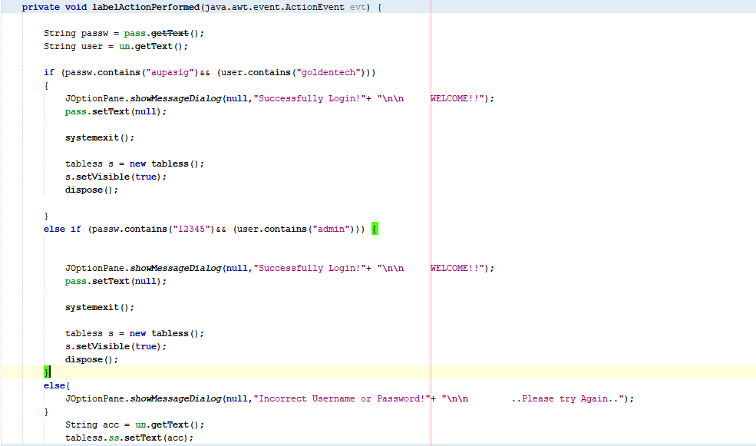 **Log-in Form**

1. **Declaring Variables, Table Headers and Table Customization**

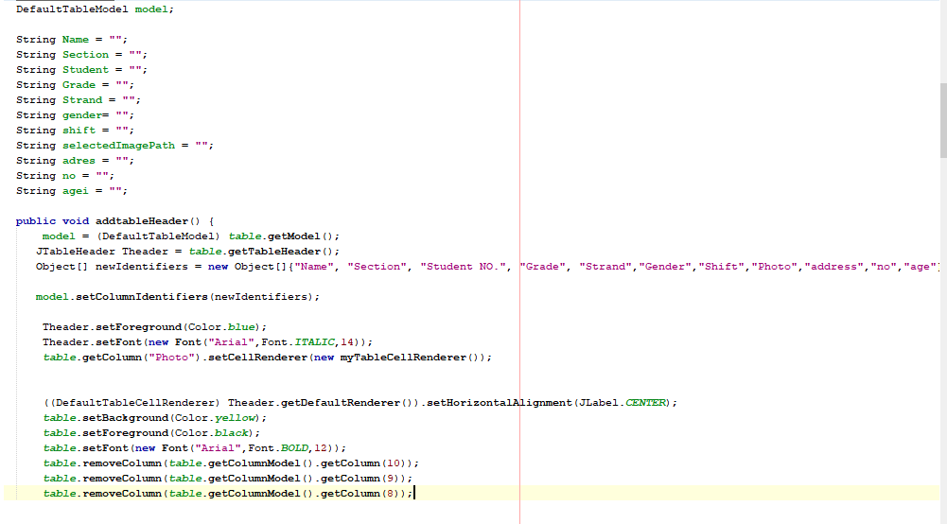

1. 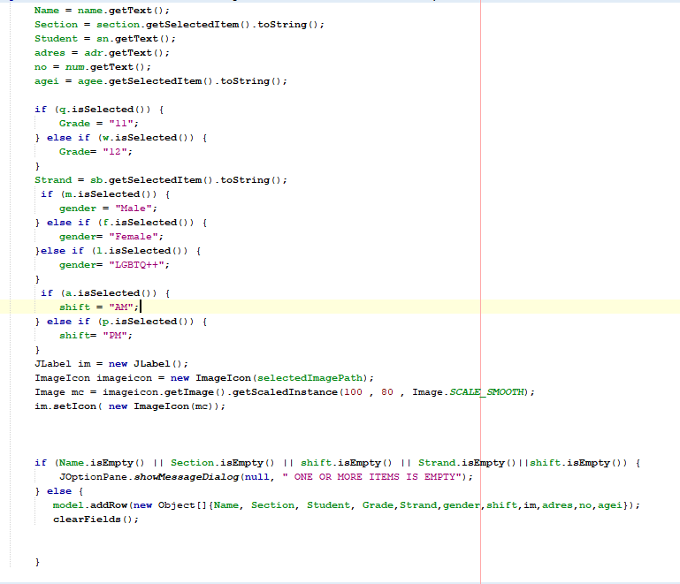**Code for Adding Text and Image For Table**
2. 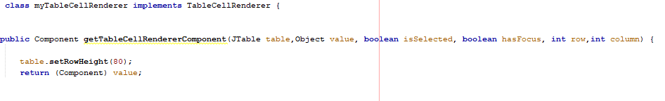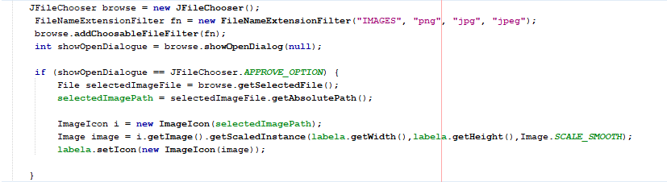**Adding and Browsing Image/Photo**

**5.)** **Search/Filter**

C:\Users\Garage88fort\Desktop\source\search2.png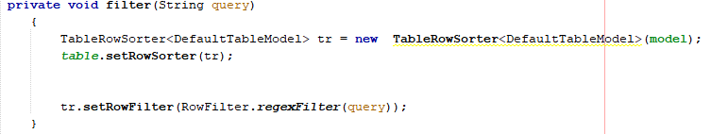

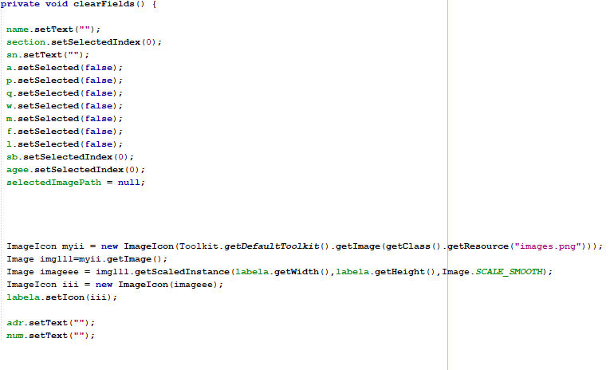**6.) Resetting Text Fields**

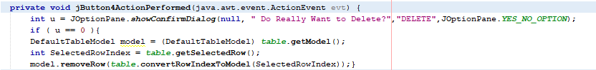**7.) Deleting Searched or Selected Row in Table**

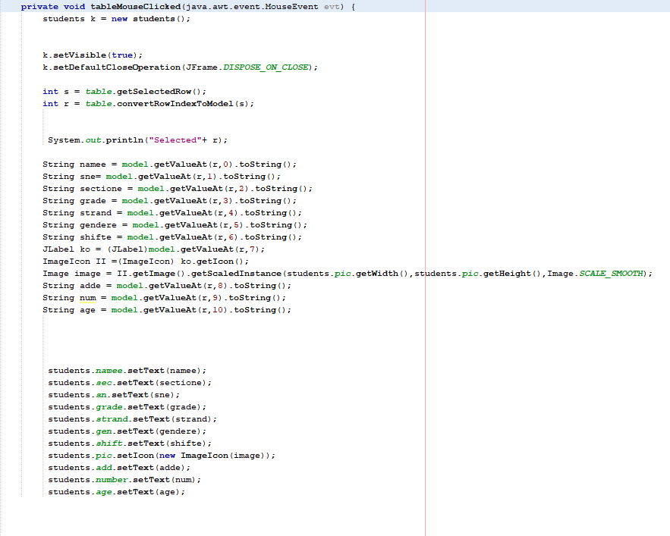**8.) Viewing Table Data In Another Frame**

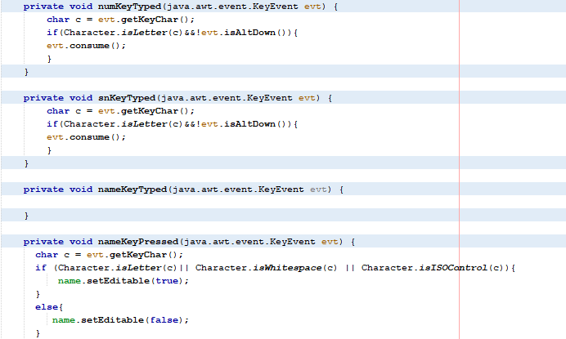**9.) Declaring Text Fields To Letters and Numbers Only**

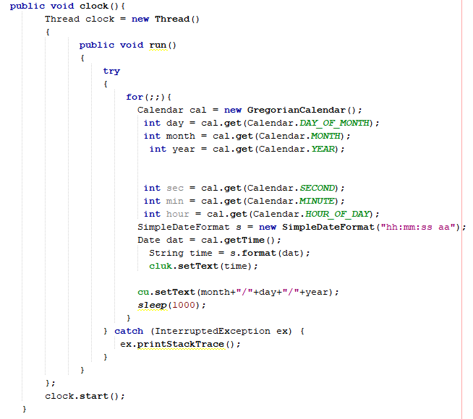 **10.) Time and Date (add-ons)**

**V. Functions:**

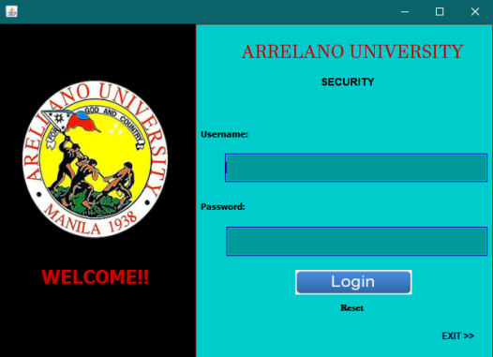1.) First you need to **Login** in our login frame to access to our main frame. You need to code if you want to add an account to our login frame to not be able to login some not authorized personnel.

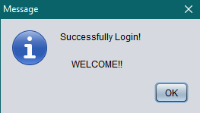2.) If you have successfully login in a login frame a message will appear that you **successfully login**.

3.) In main frame you see **a table, Text fields and buttons**. In that frame you can now fill up all the information that asking in the text fields like name, sections, student number, photos etc.

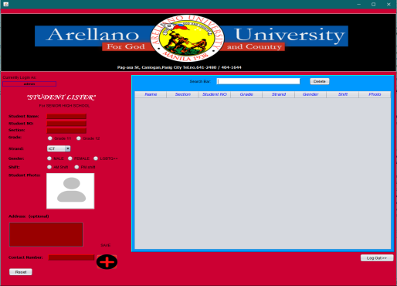

In **adding student photo**, double click the space provided and browse or locate your wanted image and click “Open”.

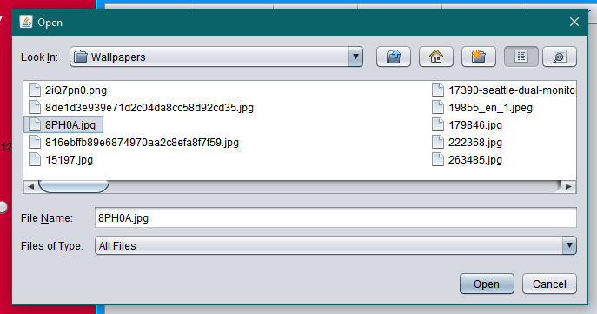

C:\Users\Garage88fort\Desktop\docu\open.png

4.) After you done Fill up or typing information asking in text field … you see a **plus black button at lower right corner** of the form, with a label of “Save”. You can now click the button and all your information you enter will show in the table. And your student is now on the list.

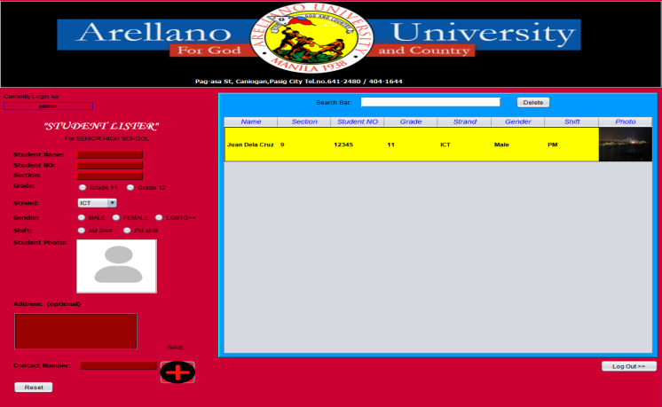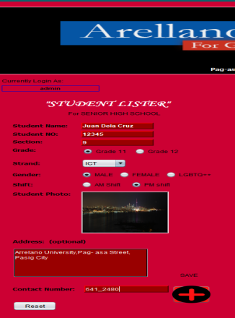



**Features:**

1. 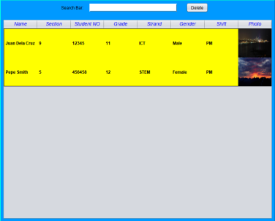**You can search students you wanted to see**.

\

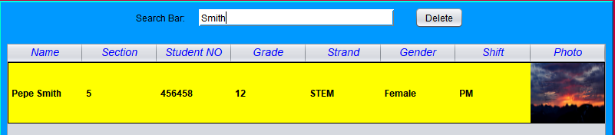

1. **You can delete student** that selected, by clicking a delete button in upper right corner of the frame.

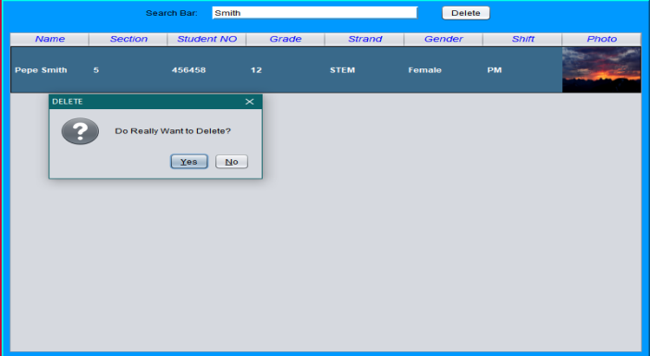

1. **You can see a clearer information and bigger picture** when you click the student you wanted to see the info because a new frame will appear containing “Student Profile”.

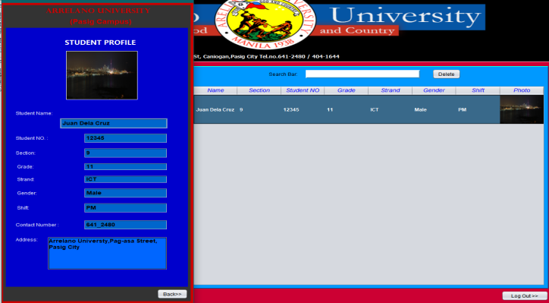

**C:\Users\Garage88fort\Desktop\docu\logout.png 4.) You can Logout** and Login another authorized personnel (admin) in the form. The button Logout is Located in lower right corner.

**New Update and Add-ons**

C:\Users\Garage88fort\Desktop\source\time.png**1.) Time and Date.** Now you can see at the right top corner of the form the working time and date label.

**2.) You cannot put numbers in “Name” Text Field. Same as “Student number and Contact Number” you cannot put letters.**

**C:\Users\Garage88fort\Desktop\source\stn.png**

**C:\Users\Garage88fort\Desktop\source\section.png3.) Updated “Section” and “Age” as Combo box option.**

**4.) Updated looks.**

**BEFORE AFTER**

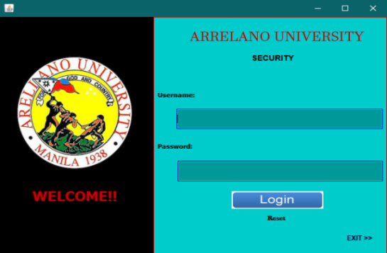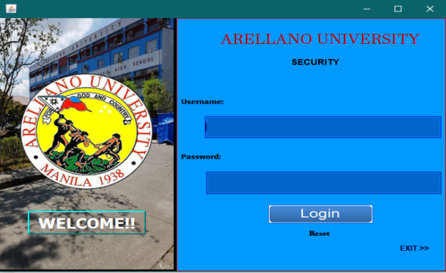**Login Frame**

**Main Frame**

(We change the table Header to the photo of the Main Building of AU Pasig and change the main frame color to light blue and change the table frame to red.)

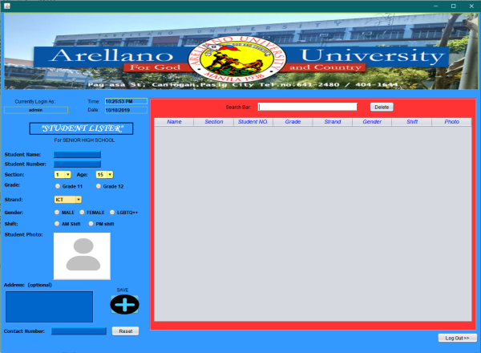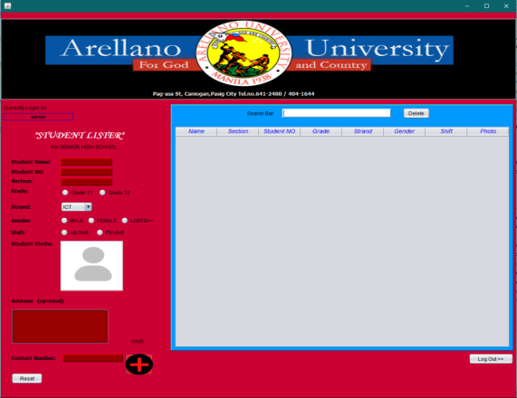

**“Student Profile” Frame**

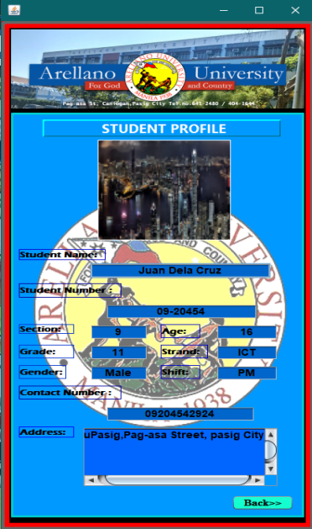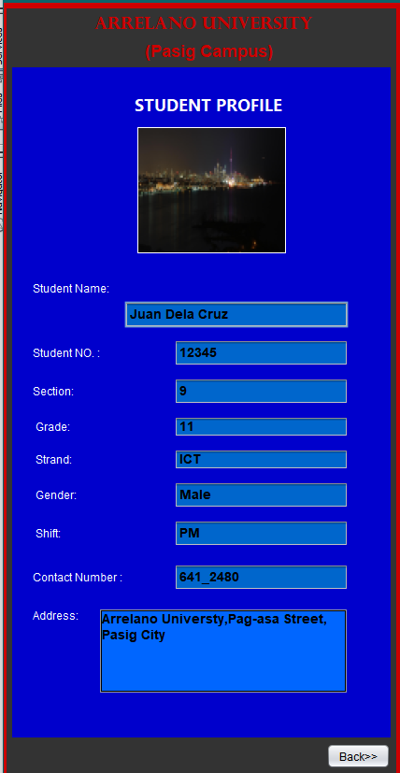

**References:**

How to Populate Jtable in Java Using Netbeans - Display Data From User Input

<https://www.youtube.com/watch?v=mIeoTjAE14E&t=1108s>

How to Display and Insert Image into JTable Cell from Computer - Java GUI - NetBeans IDE tutorial

<https://www.youtube.com/watch?v=vFItm64F6GU&t=1123s>

How to Clear Or Reset Input Field On Button Click Java Jframe Swing Tutorial - Netbeans

<https://www.youtube.com/watch?v=m2_8HARrVHY>

Browse For Image File And Display It On Jlabel Using Java Swing

<https://www.youtube.com/watch?v=p4HV2zDcANI>

 Filter/Search Using JTextField

<https://www.youtube.com/watch?v=Uq4v-bIDAIk&t=657s>

How To Remove JTable Selected Row In Java Using NetBeans

<https://www.youtube.com/watch?v=ytV80z6XgPw>

How to Open New Jframe From A jButton in Netbeans java

<https://www.youtube.com/watch?v=Ml2b6XBunMI&t=240s>

How to display digital clock in java swing using NetBeans

<https://www.youtube.com/watch?v=21r5FkzSUqU&t=907s>

Make jtextField Accept only numbers and decimal point

<https://www.youtube.com/watch?v=vQCi8tJLU9k>

How to validate JTextField to accept only alphabets By Using NetBeans | JAVA Swing

<https://www.youtube.com/watch?v=C6x_TgJH444&t=361s>

**Conclusion:**

After watching and learning some tutorials in YouTube, we created and program this application in Jframe in Net Beans that can resolve the problem in our School. We think a solution that will get some chance to students who forgot there I.D’s. when they coming to school.

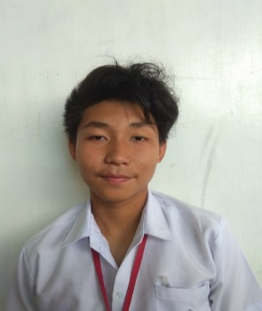**CURRICULUM VITAE**

Pintor, Kyle T.

Blk 9, Lot 8, Villa Balderama. Nagpayong II Pinagbuhatan Pasig City

1. **Personal Background**:

**Place of Birth**: San Juan City

**Gender:** Male

**Religion:** Catholic

**Civil Status:** Single

**Citizenship:** Filipino

1. **Educational Background:**

**Secondary:** Nagpayong High School

**Primary:** Nagpayong Elementary School

1. **Family Background:**

**Father’s name:** Franklin L. Pintor

**Mother’s name:** Maria T. Pintor

 **CURRICULUM VITAE**

Dexter Jones M. Perol

272 Esguerra St. Pinagbuhatan Pasig City

**A**. **Personal Background:**

**Place of Birth:** Pasig City

**Gender:** Male

Religion: Catholic

Civil Status: Single

Citizenship: Filipino

**B. Educational Background:**

**Secondary:** Rizal High School

**Primary:** Pasig Central Elementary School

**C. Family Background:**

**Father’s name:** Ranulfo L. Perol

**Mother’s name:** Magdalena S. Perol

  **CURRICULUM VITAE**

Jysrel Carl Reniel G. Sula

103 B. Dr. Pipapil St. Sagad, Pasig City

1. **Personal Background:**

**Place of Birth:** Pasig City

**Gender:** Male

**Religion:** Christian

**Civil Status:** Single

**Citizenship:** Filipino

1. **Educational Background:**

**Secondary:** Sagad High School

**Primary:** Sagad Elementary School

1. **Family Background:**

**Father’s name:** Renato M. Sula

**Mother’s name:** Carlota G. Sula  **CURRICULUM VITAE**

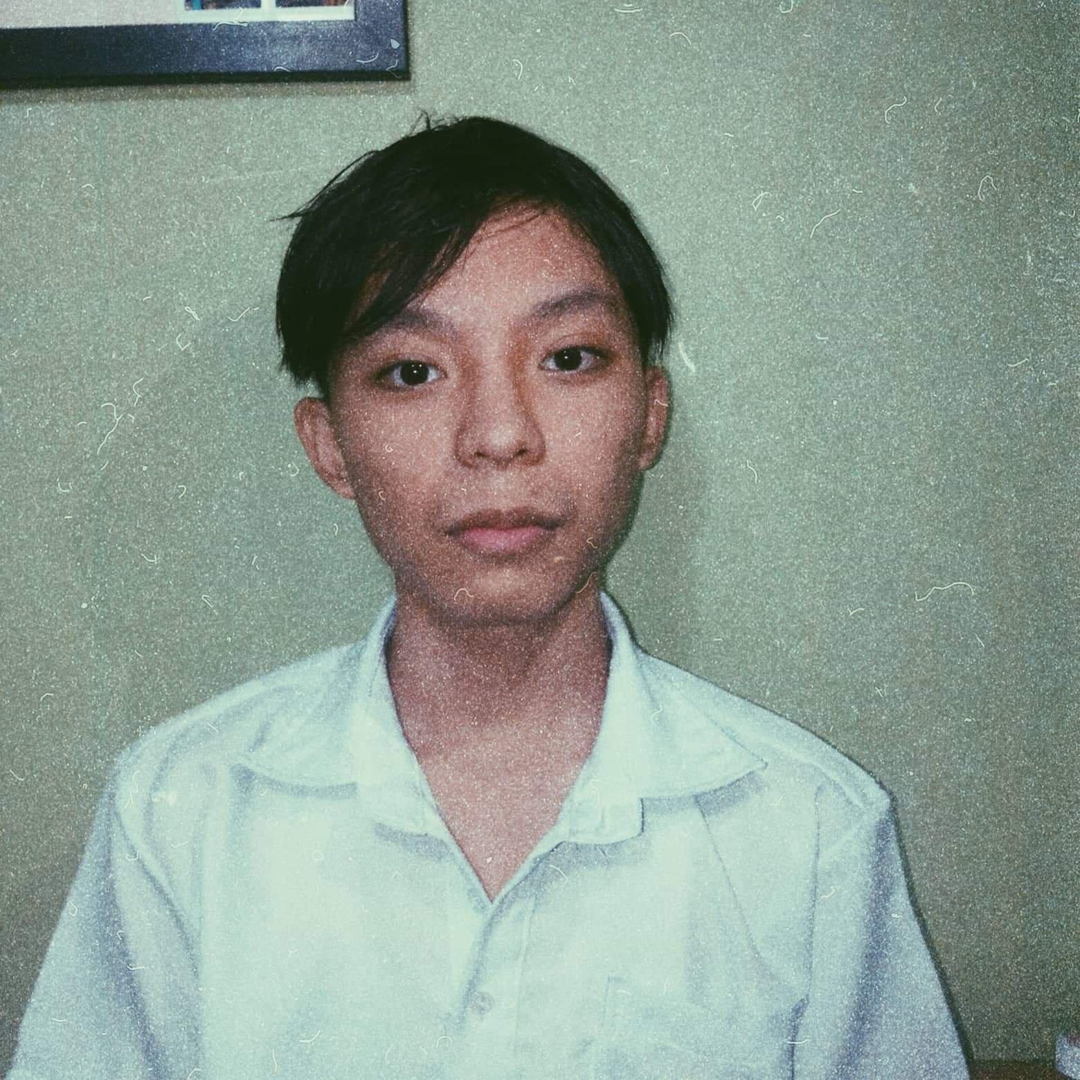

Edgardo M. Magada

187 Dr. Pilapil St. San Miguel Pasig City

**A. Personal Background:**

**Place of Birth:** Pasig City

**Gender:** Male

**Religion:** Catholic

**Civil Status:** Single

**Citizenship:** Filipino

**B. Educational Background:**

**Secondary:** Pasig Central Elementary School

**Primary:** Sagad High School

**C. Family Background**:

**Father’s name**: Edgardo Q. Magada

**Mother’s name:** Shirley M. Magada

 **CURRICULUM VITAE**

Jay Iverson Oblepias

95 Noche Buena St Villarosa Sto Tomas Pasig City

**A. Personal Background:**

**Place of Birth:** Pasig City

**Gender:** Male

**Religion:** Catholic

**Civil Status:** Single

**Citizenship:** Filipino

**B. Educational Background:**

**Secondary:** Sagad High School

**Primary**: Palatiw Elementary School

**C. Family Background:**

**Father’s name:** Arturo B. Oblepias

**Mother’s name:** Rosalinda Oblepias

 **CURRICULUM VITAE**

Christian Miles G. Valdepeña

73 E. Ragas St. Pateros Sta Ana. Metro Manila

**A. Personal Background:**

**Place of Birth:** Pasig City

**Gender:** Male

**Religion:** Christian

**Civil Status:** Single

**Citizenship:** Filipino

**B. Educational Background:**

**Secondary:** Pateros National High School

**Primary:** Capt. H. Francisco Elementary School (MAIN)

**C. Family Background:**

**Father’s name:** Marlon Valdepeña

**Mother’s name:** Gemma Valdepeña

 **CURRICULUM VITAE**

Getalado, Alvin P.

5057 Venus ST. brgy Sanjuan Cainta Rizal

**A. Personal Background:**

**Place of Birth:** Northern Samar

**Gender:** Male

**Religion:** Jehovas Witnesses

**Civil Status:** Single

**Citizenship:** Filipino

**B. Educational Background:**

**Secondary:** Cabatuan National Highschool

**Primary:** San Francisco Elementary School

**C. Family Background**

**Father’s name:** Nelson C. Getalado

**Mother’s name:** Ailyn P. Getalado

  **CURRICULUM VITAE**

Pendon, Mevin Delantar

Narra St, Pinagbuhatan, Pasig city

**A. Personal Background:**

**Place of Birth**: Pasig City

**Gender:** Male

**Religion:** Catholic

**Civil Status:** Single

**Citizenship:** Filipino

**B. Educational Background:**

**Secondary:** Nagpayong High School

**Primary:** Nagpayong Elementary School

**C. Family Background:**

**Father’s name:** Ruben Pendon.D

**Mother’s name:** Melody Pendon